**BDM 1034 - Application Design for Big Data**

**Lab4**

**Submitted by: Aadarsha Chapagain**

**Student ID:C0825975**

**Submitted to: Prof. Teresa Zhu**

Here I have attached the certificate I achieved from Linkedin learning for Course “**Program Databases with Transact-SQL”** along with the Screenshot of score I achieved

**Chapter 1:**

**Save Query as view object**

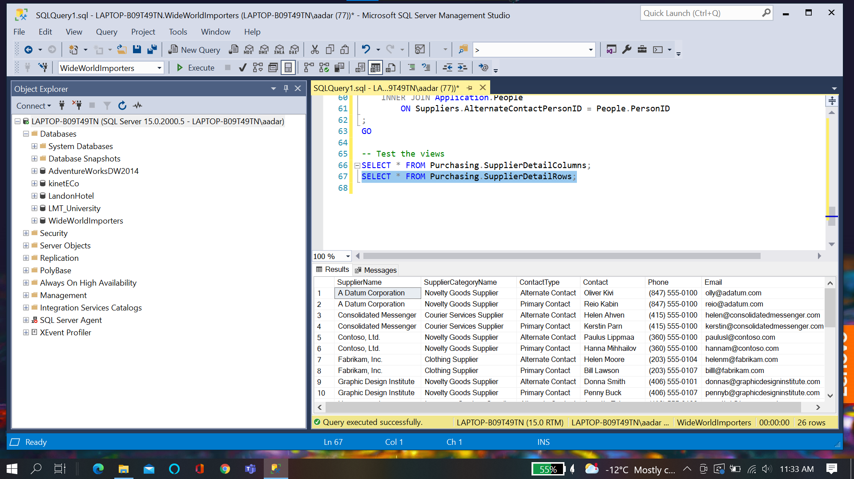

**Exploring existing views:**

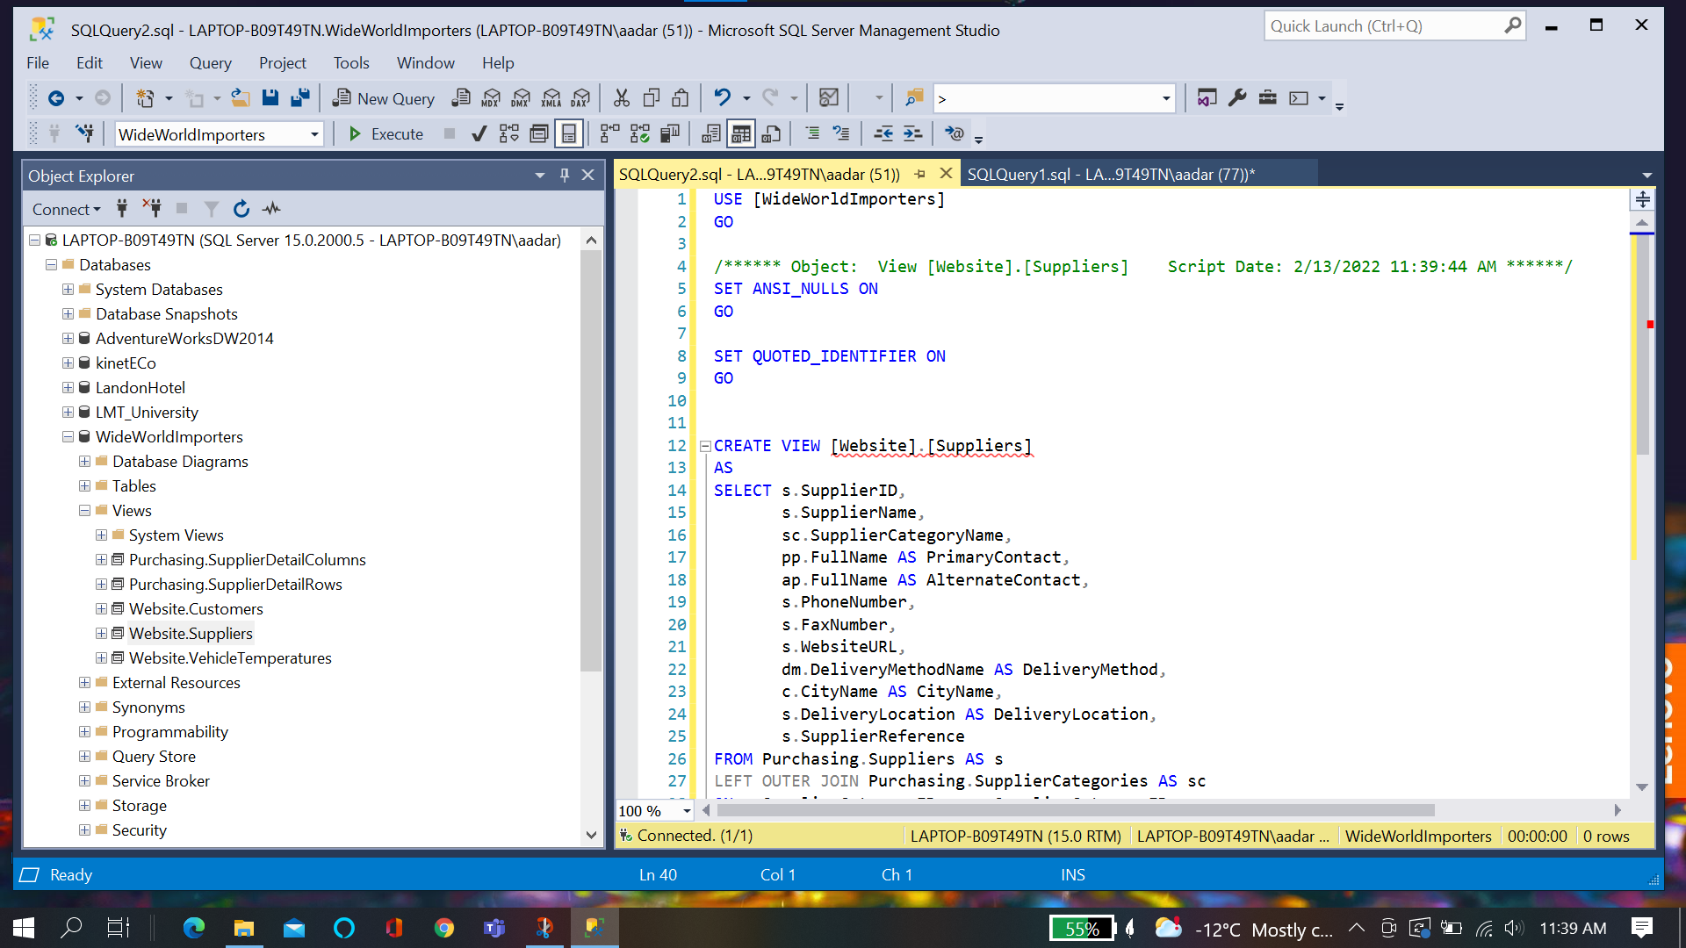

**Schema Binding:**

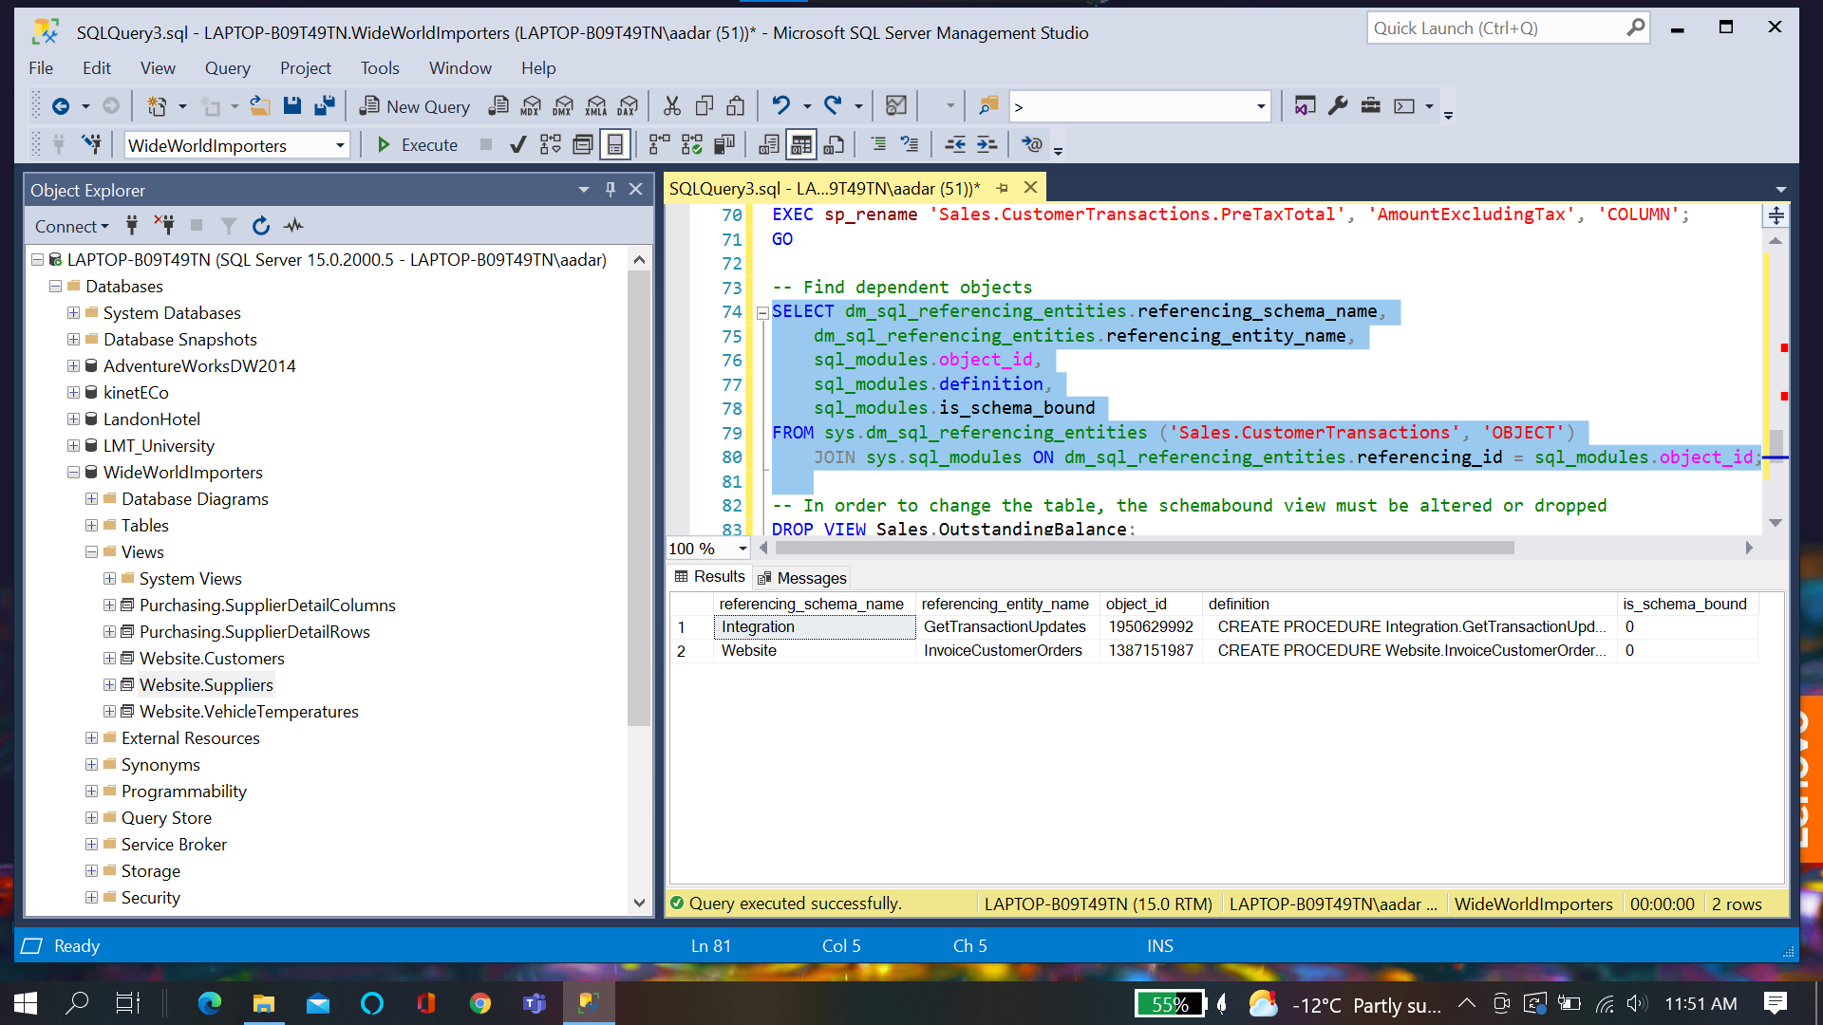

**View Object with indexes:**

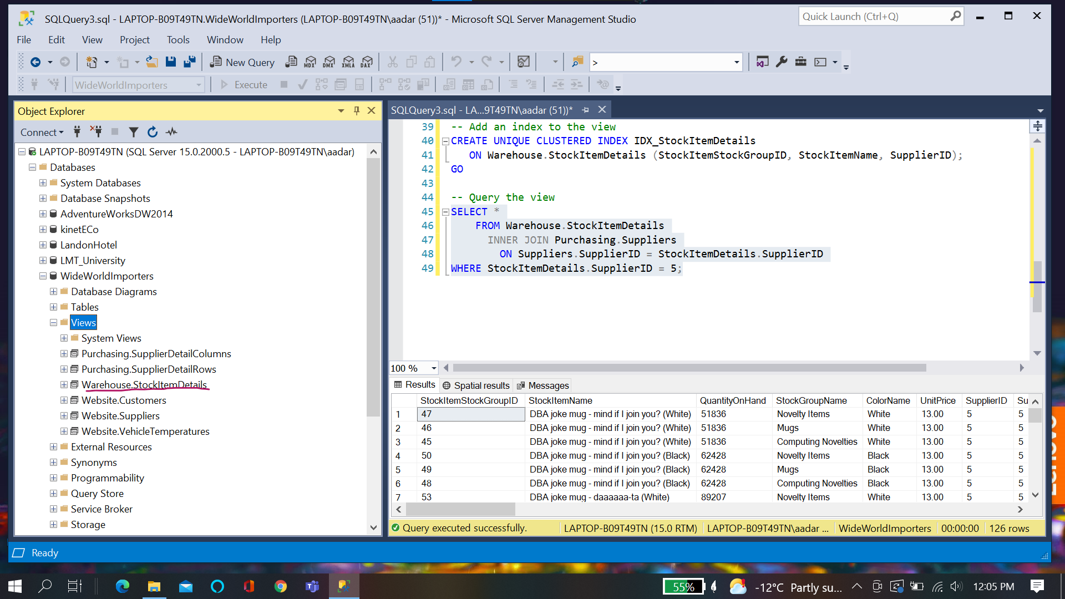

**Chapter Quiz**

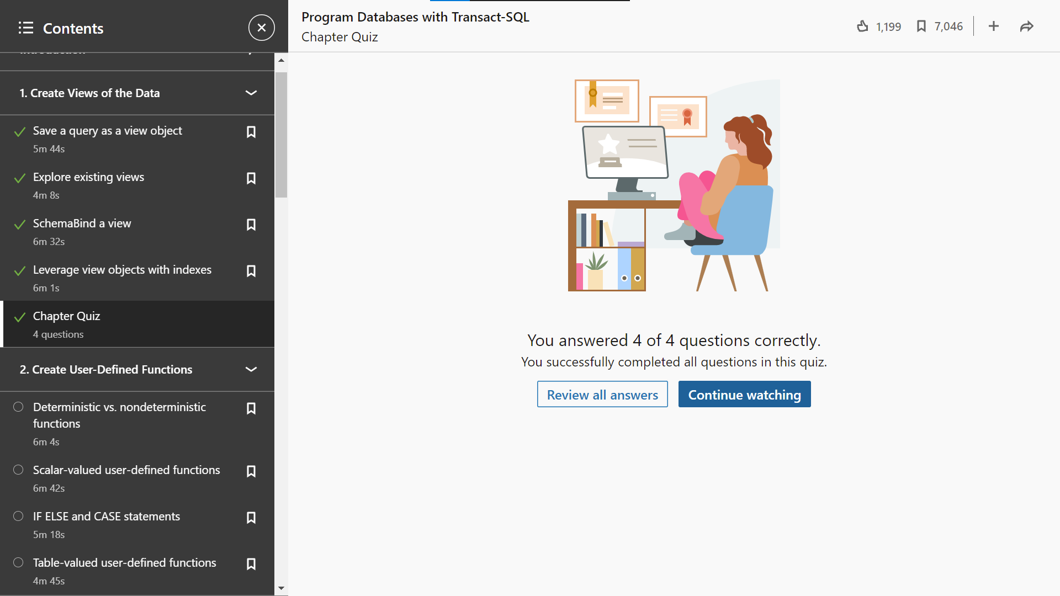

Chapter 2: **Create User defined functions**

**Deterministic VS Non deterministic function**

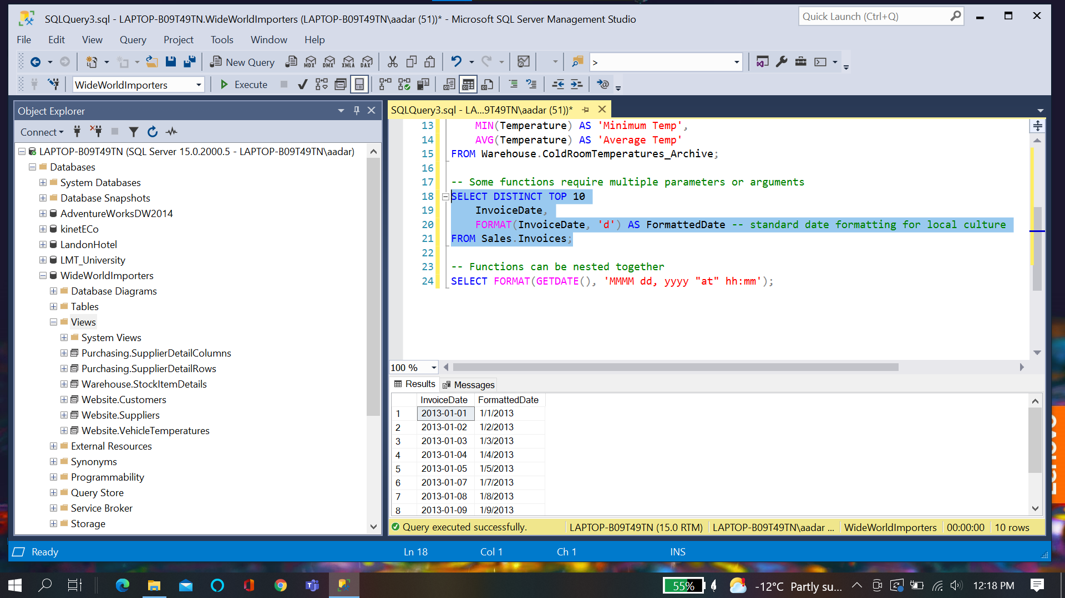

**Scalar Valued Used-defined functions**

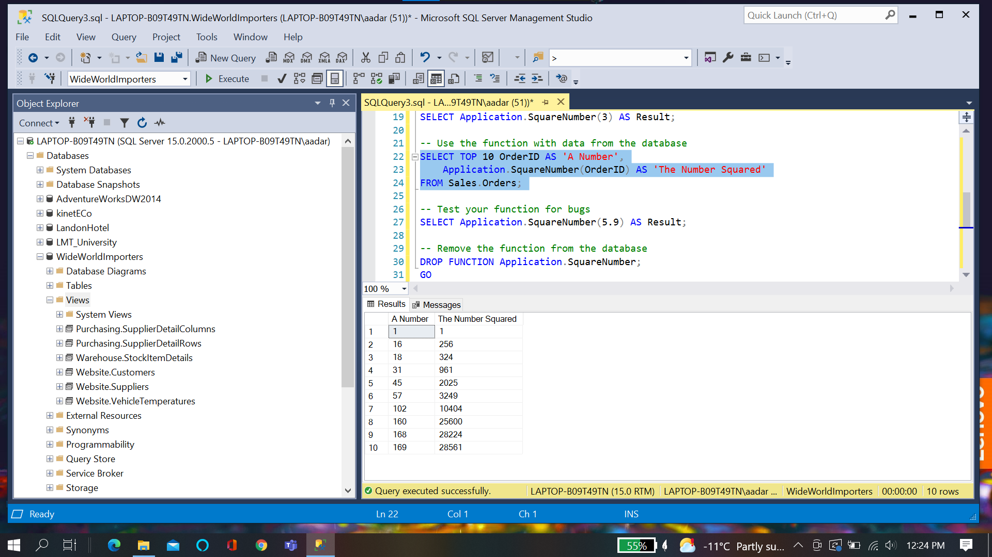

**If Else Case Statement:**

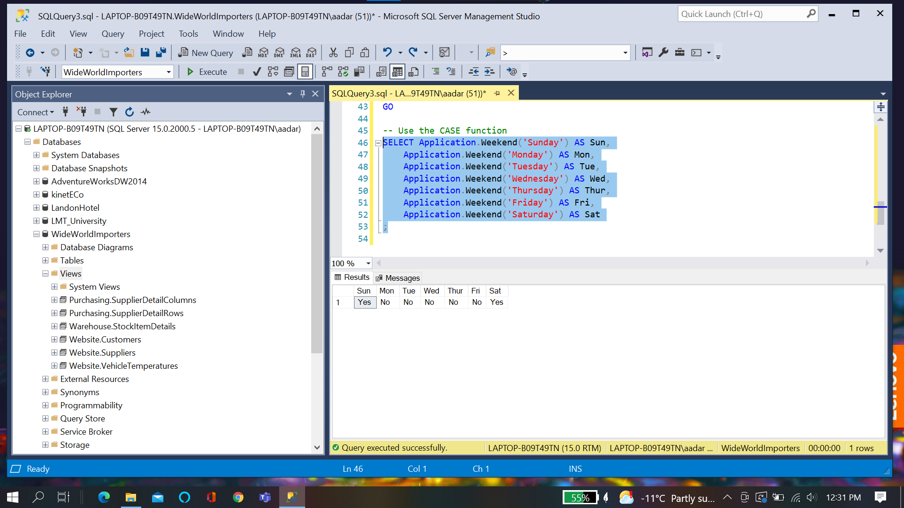

**User Defined Table Valued function:**

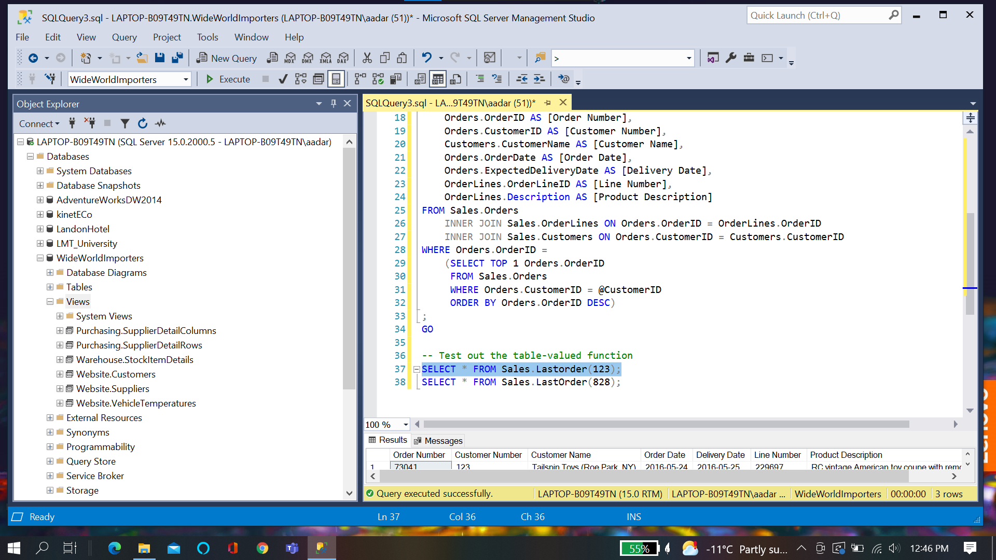

**Challenge:**

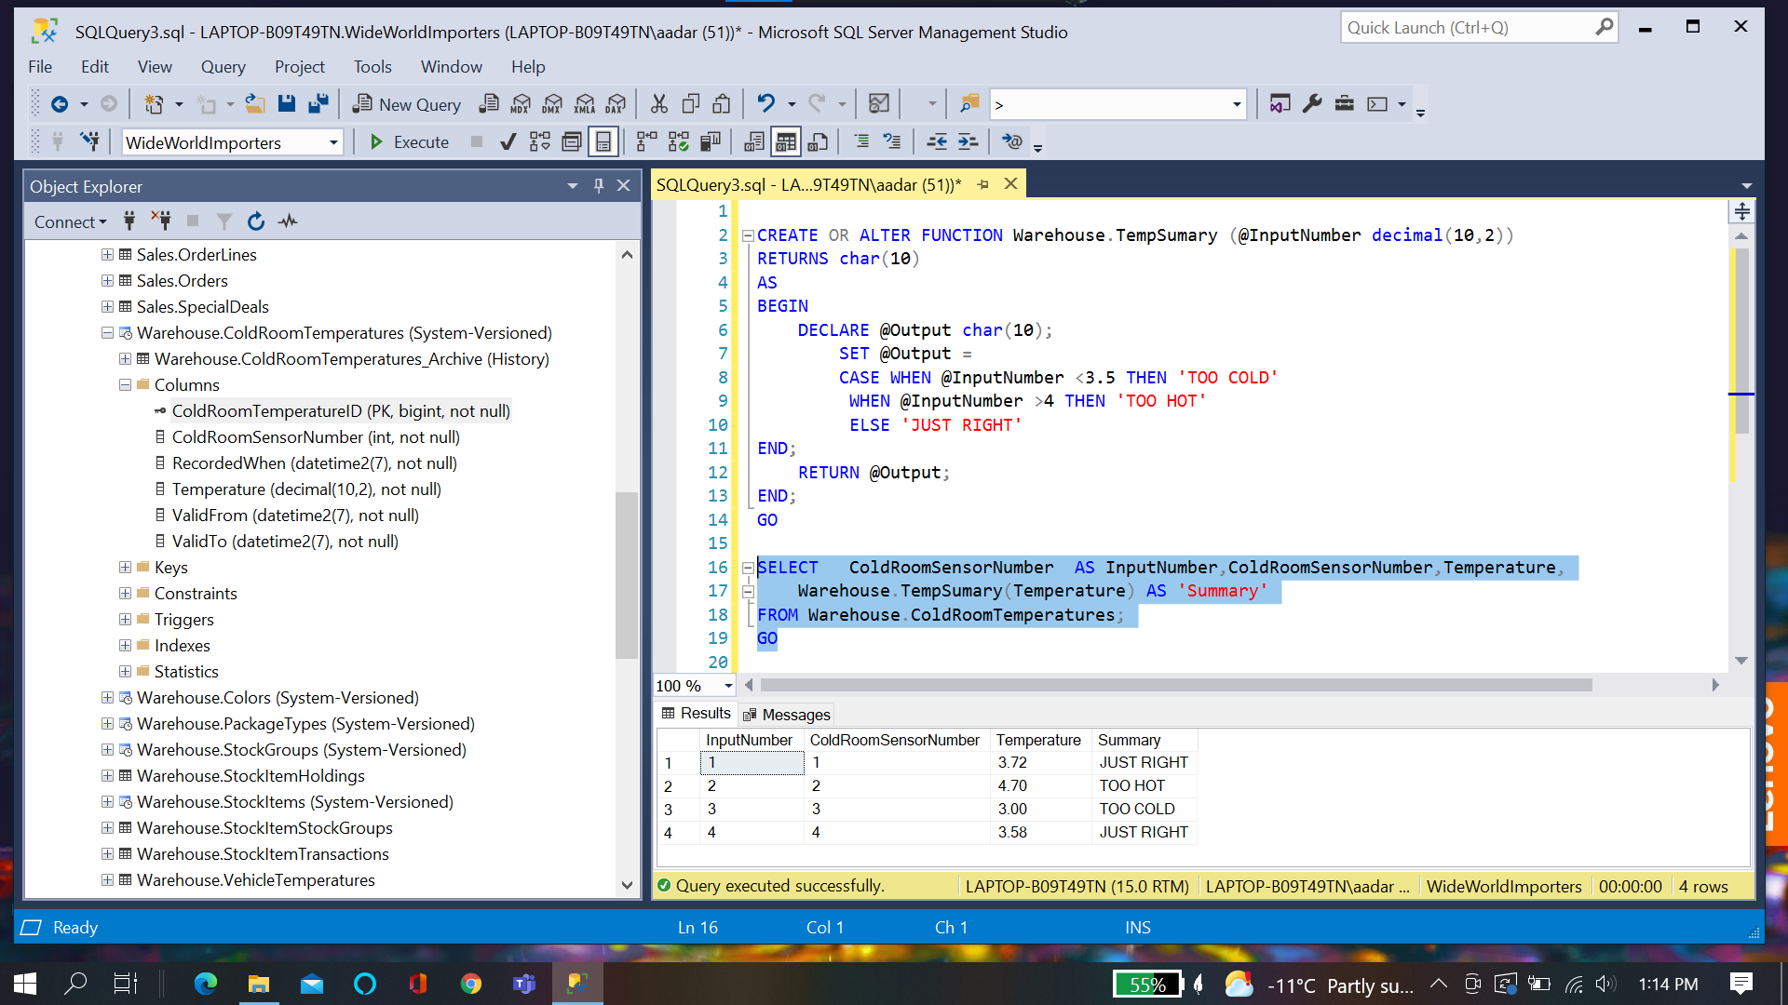

**Chapter Quiz:**

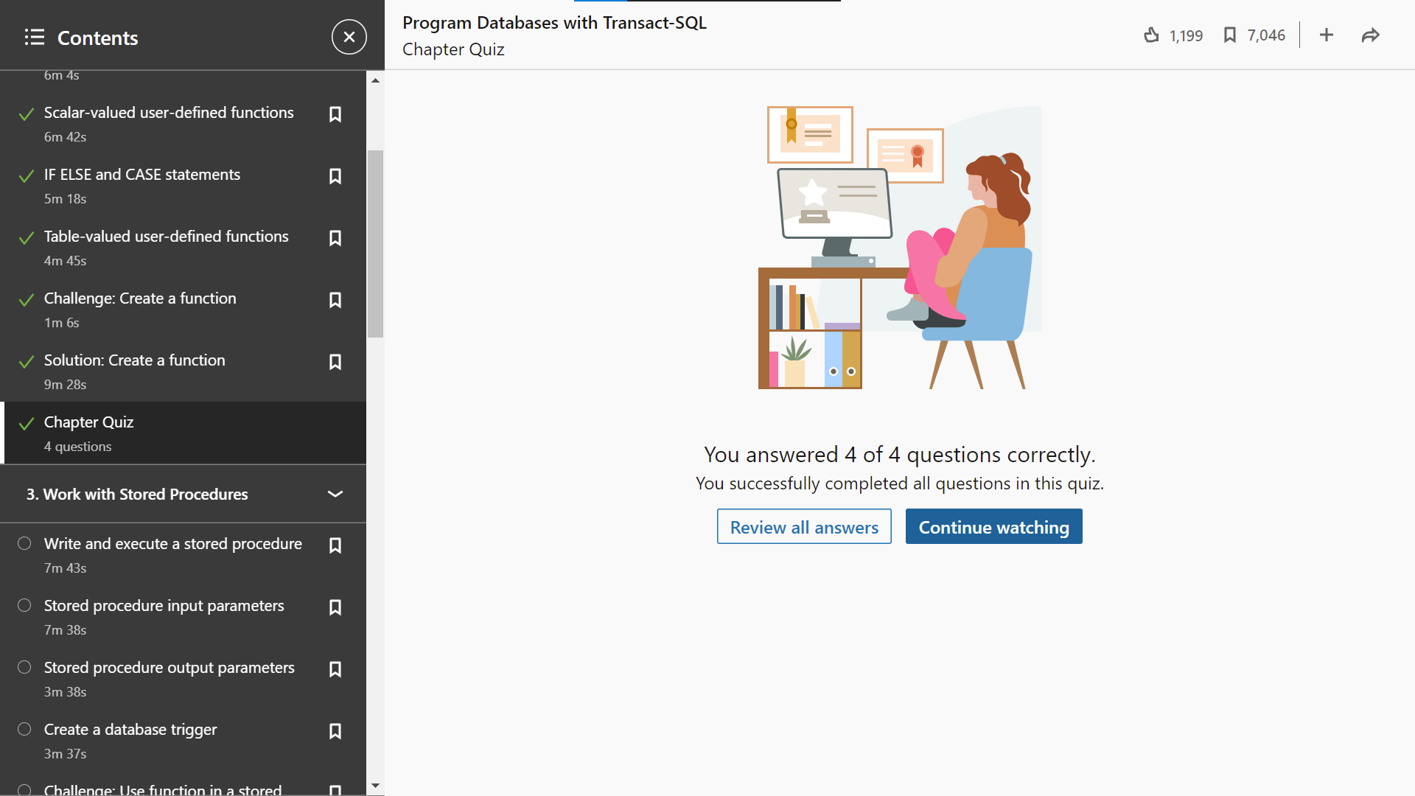

**Chapter 3: Stored Procedure**

**Execute Stored procedure**

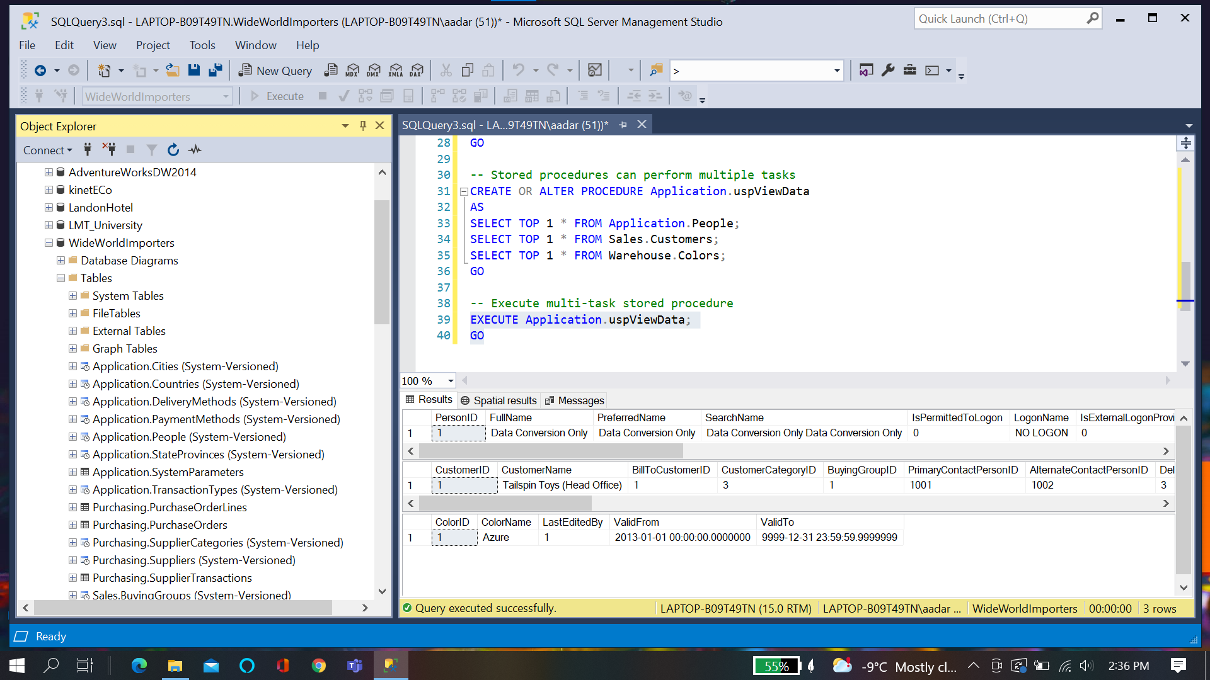

**Stored Procedure Output Parameter:**

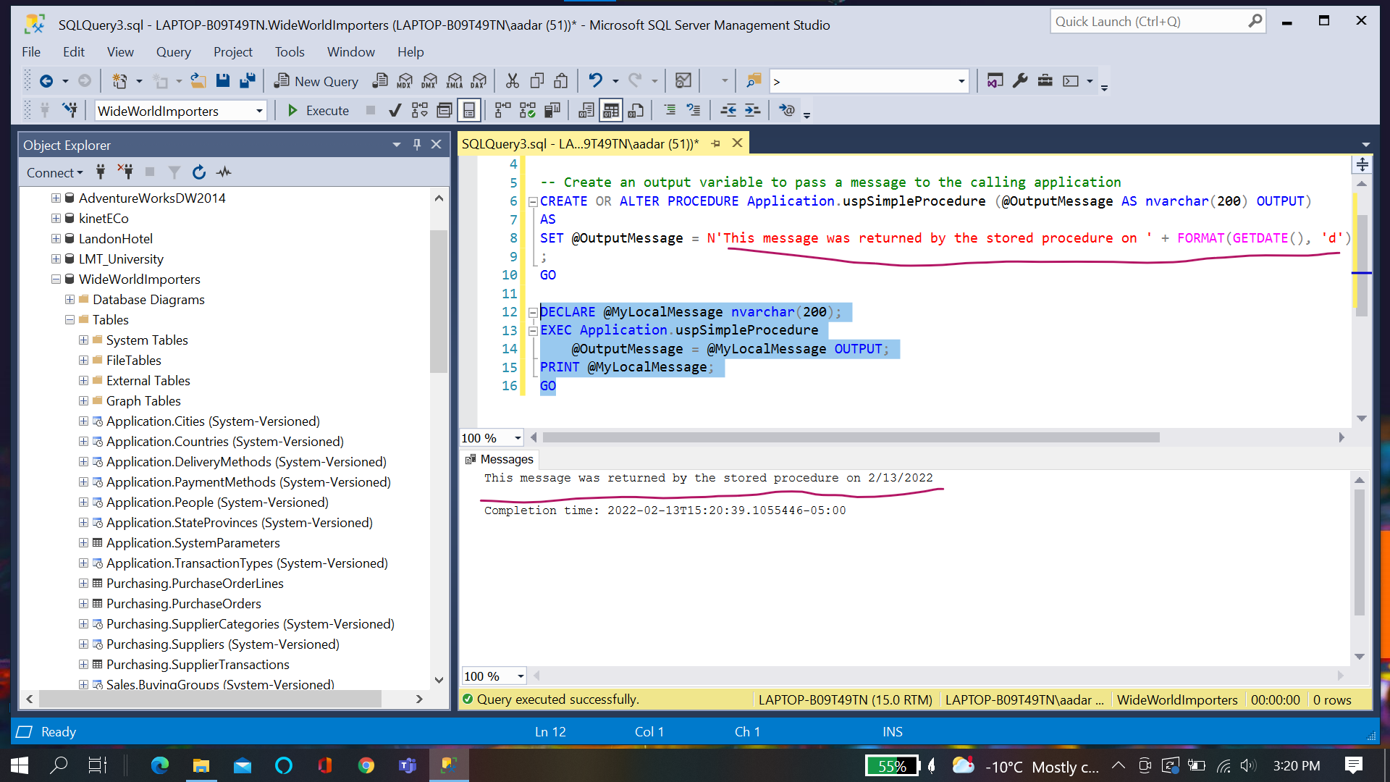

**Trigger:**

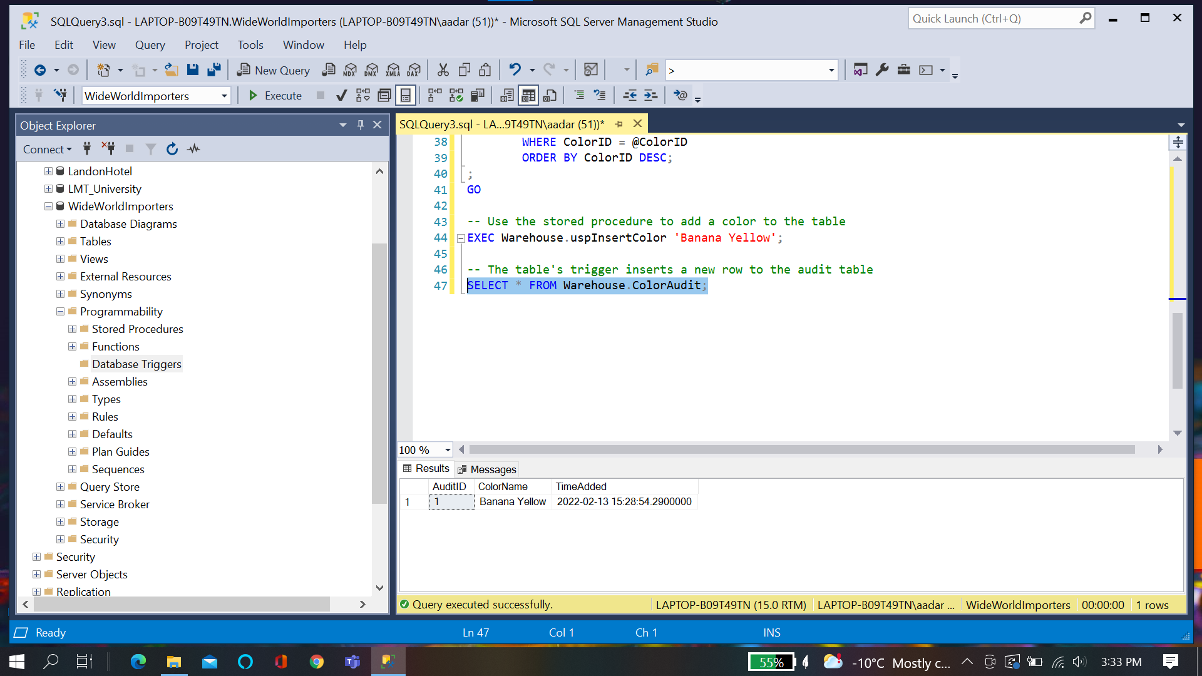

**Challenge:**

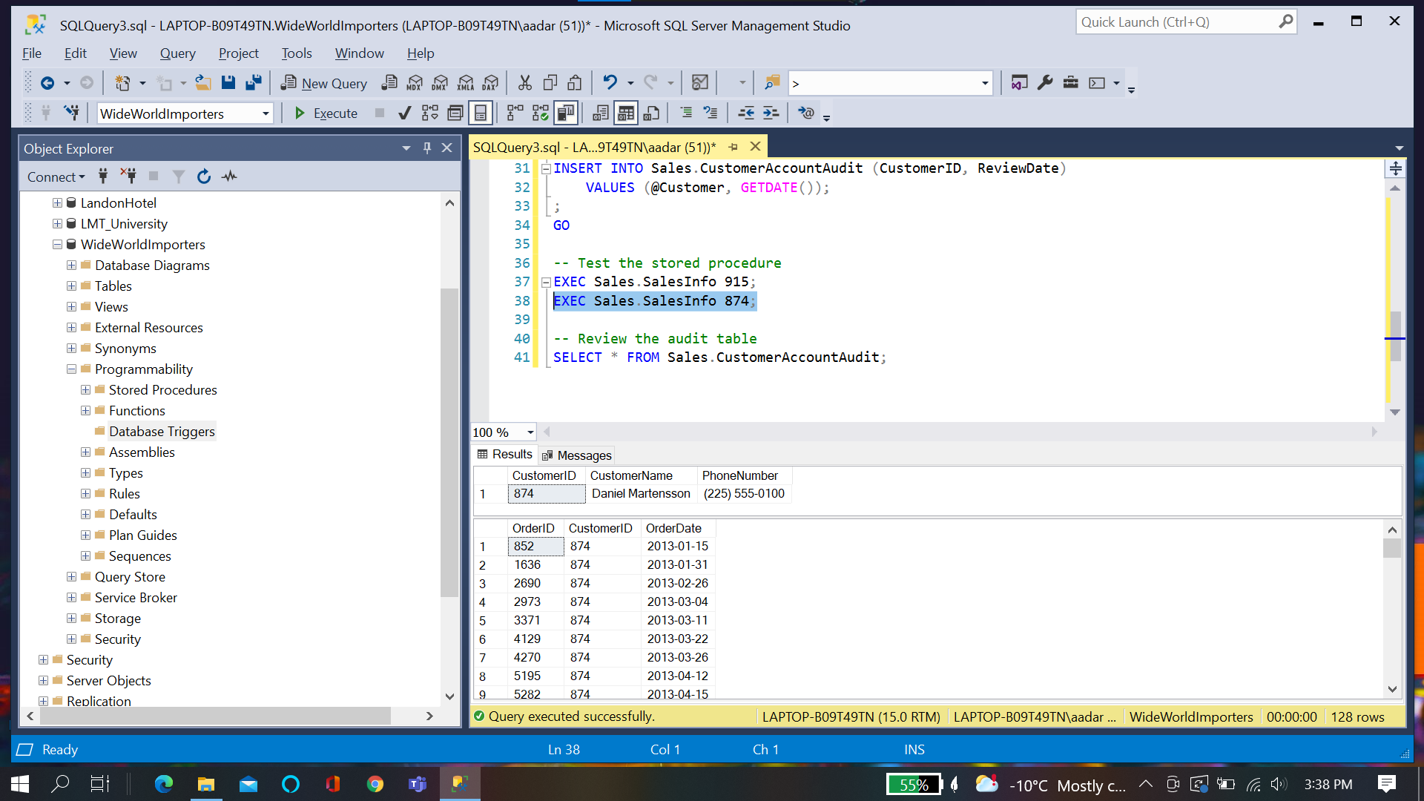

**Chapter quiz:**

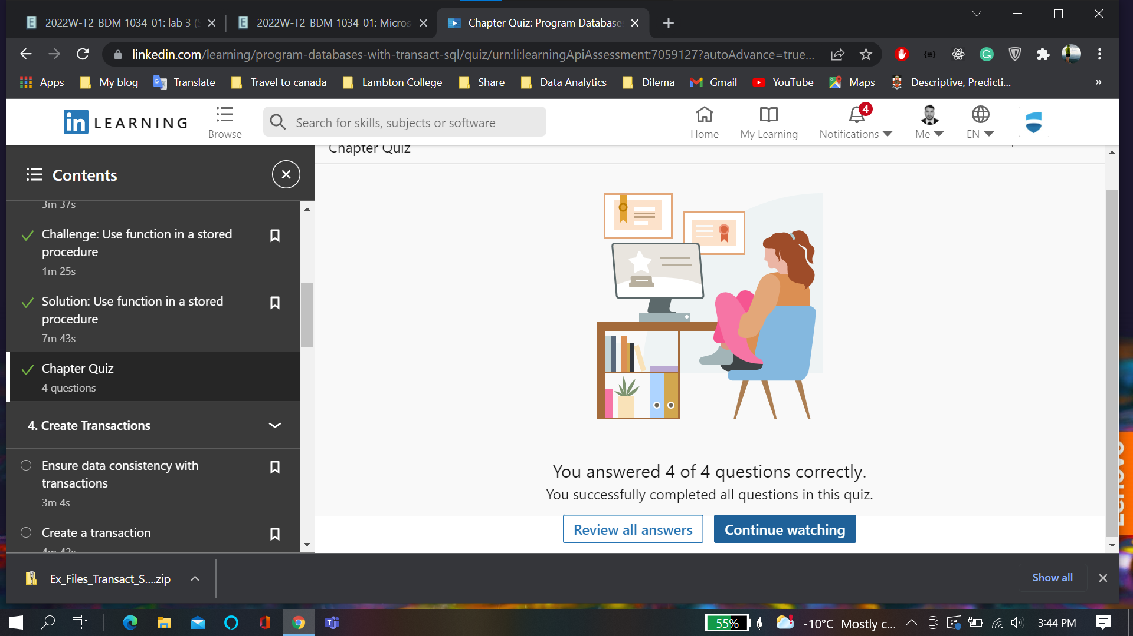

**Chapter 4: Transactions**

**Create Transaction**

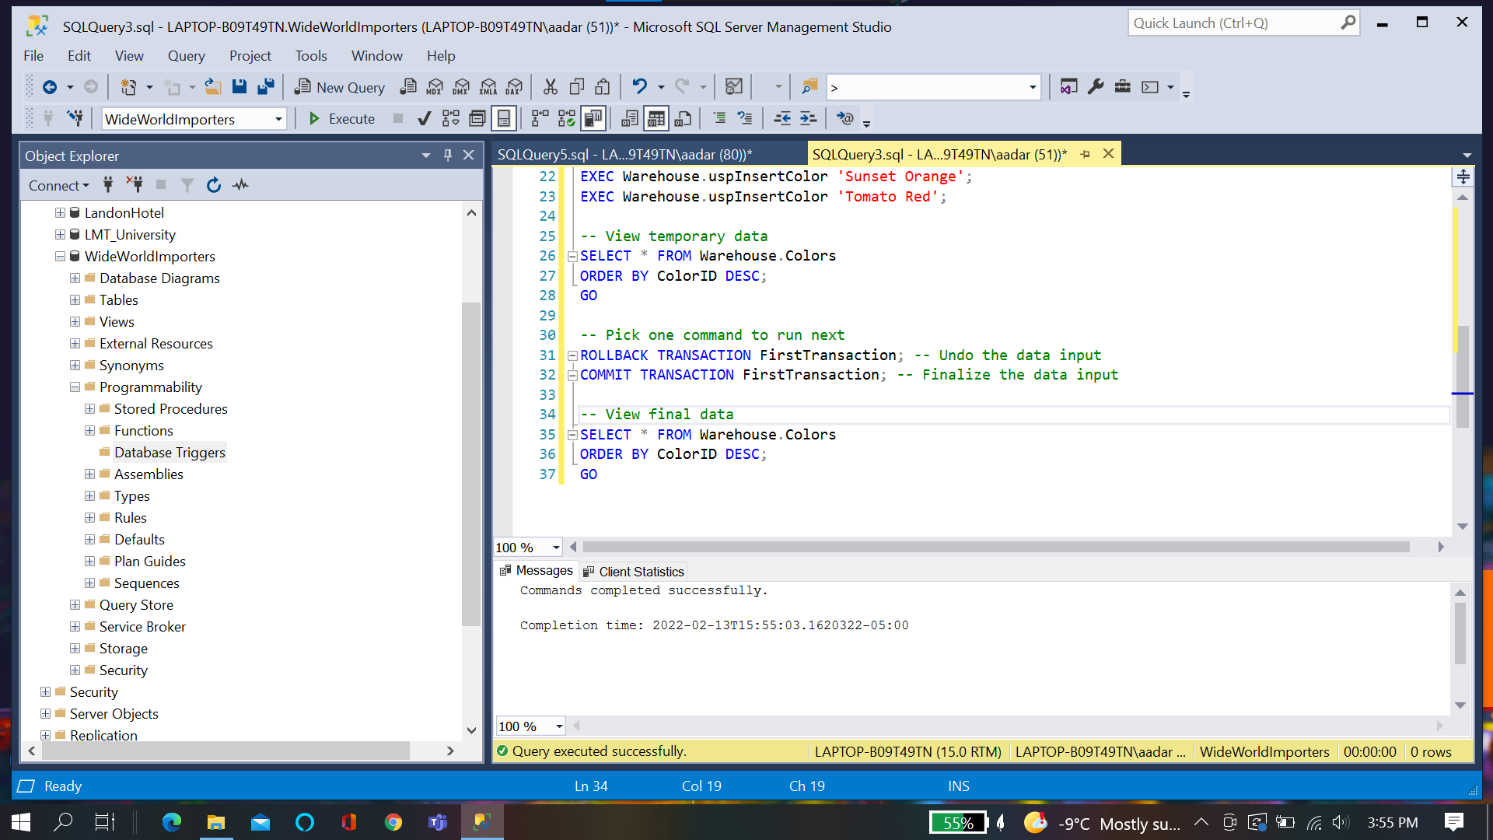

**Transactions Save point:**

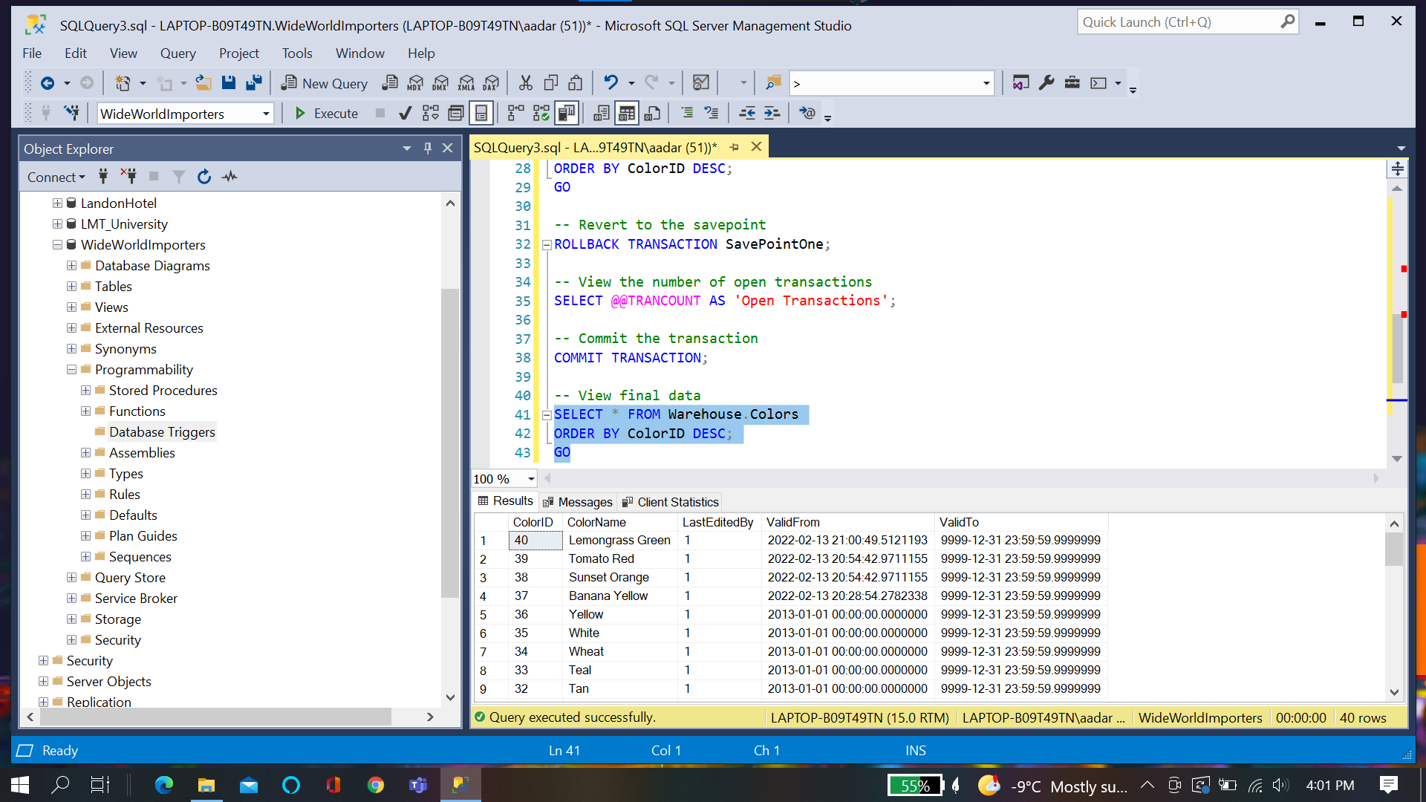

**Automatic Rollback Transactions**

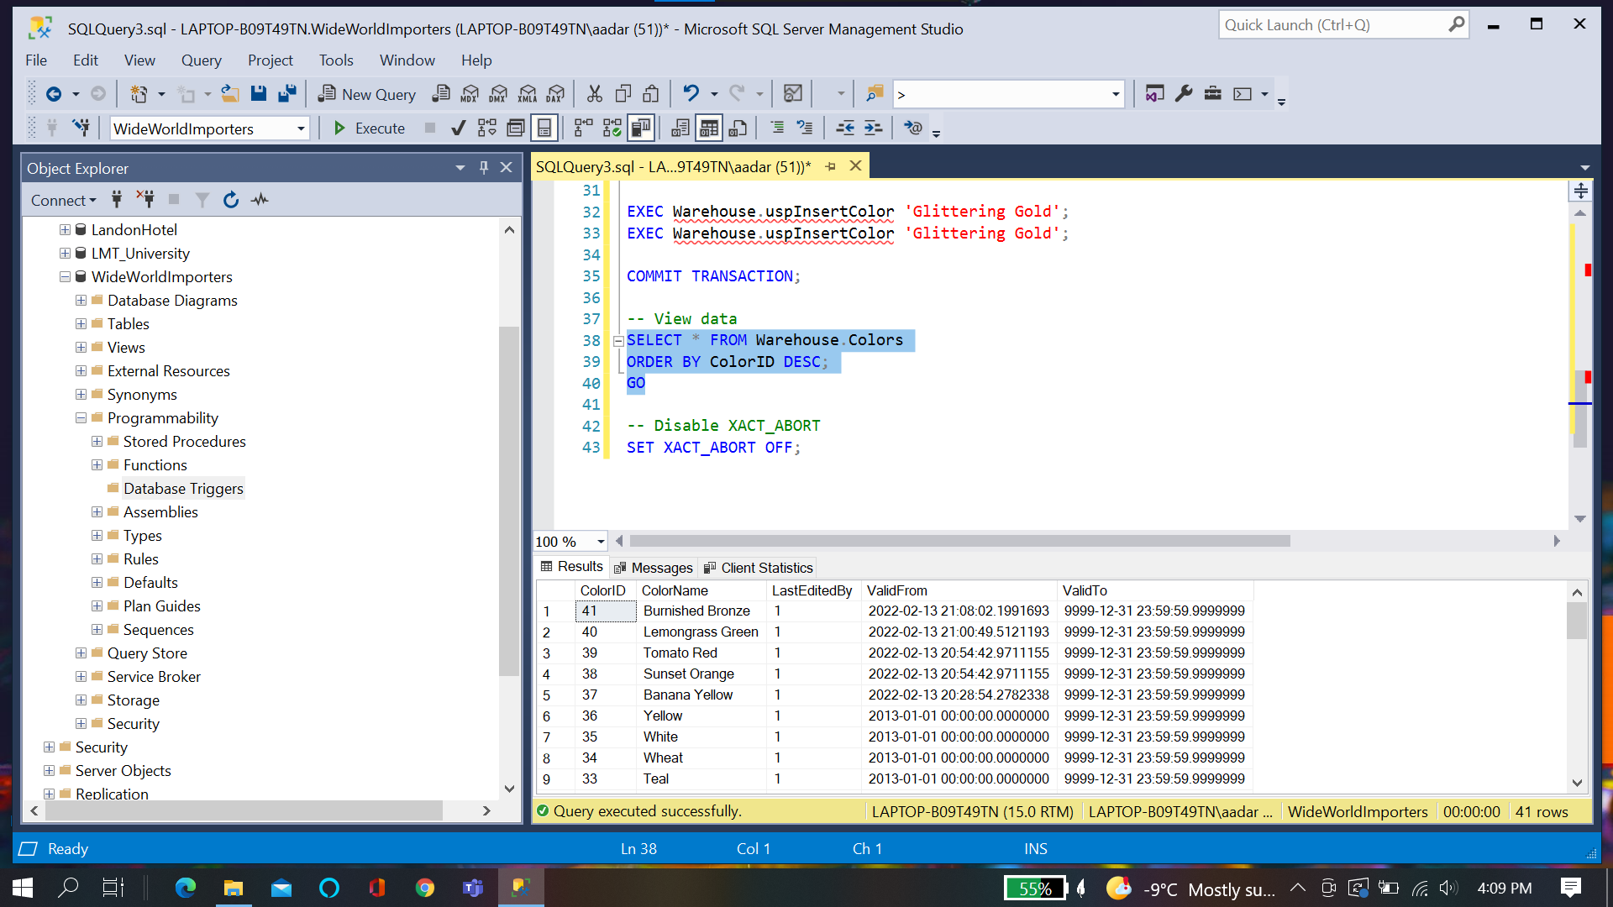

**Challenge:**

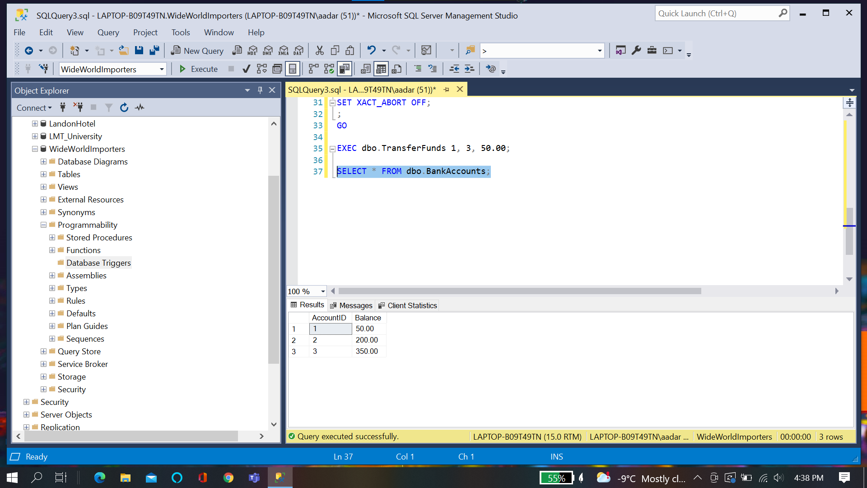

**Quiz:**

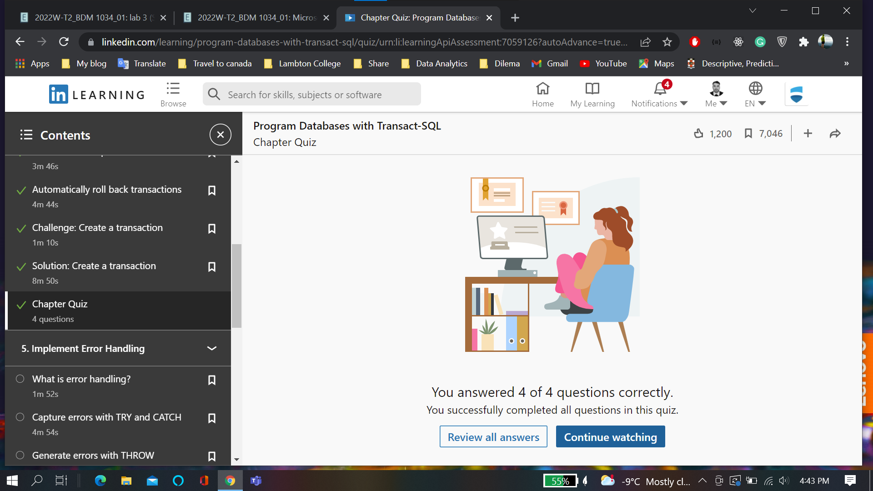

**Chapter 5:Error Handling**

**Errors with try catch:**

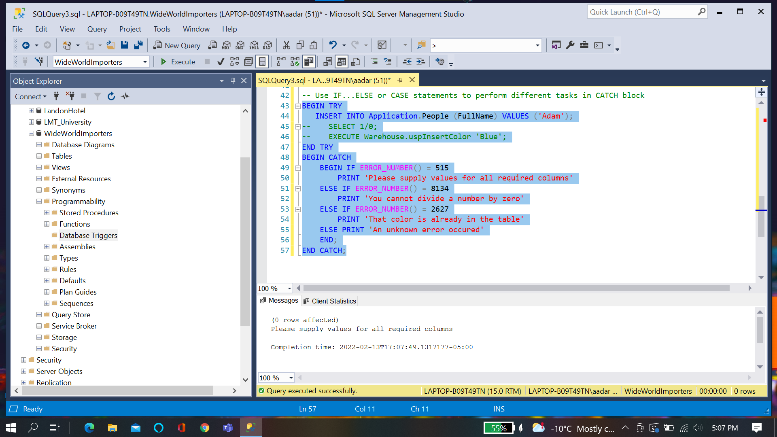

**Errors with throw:**

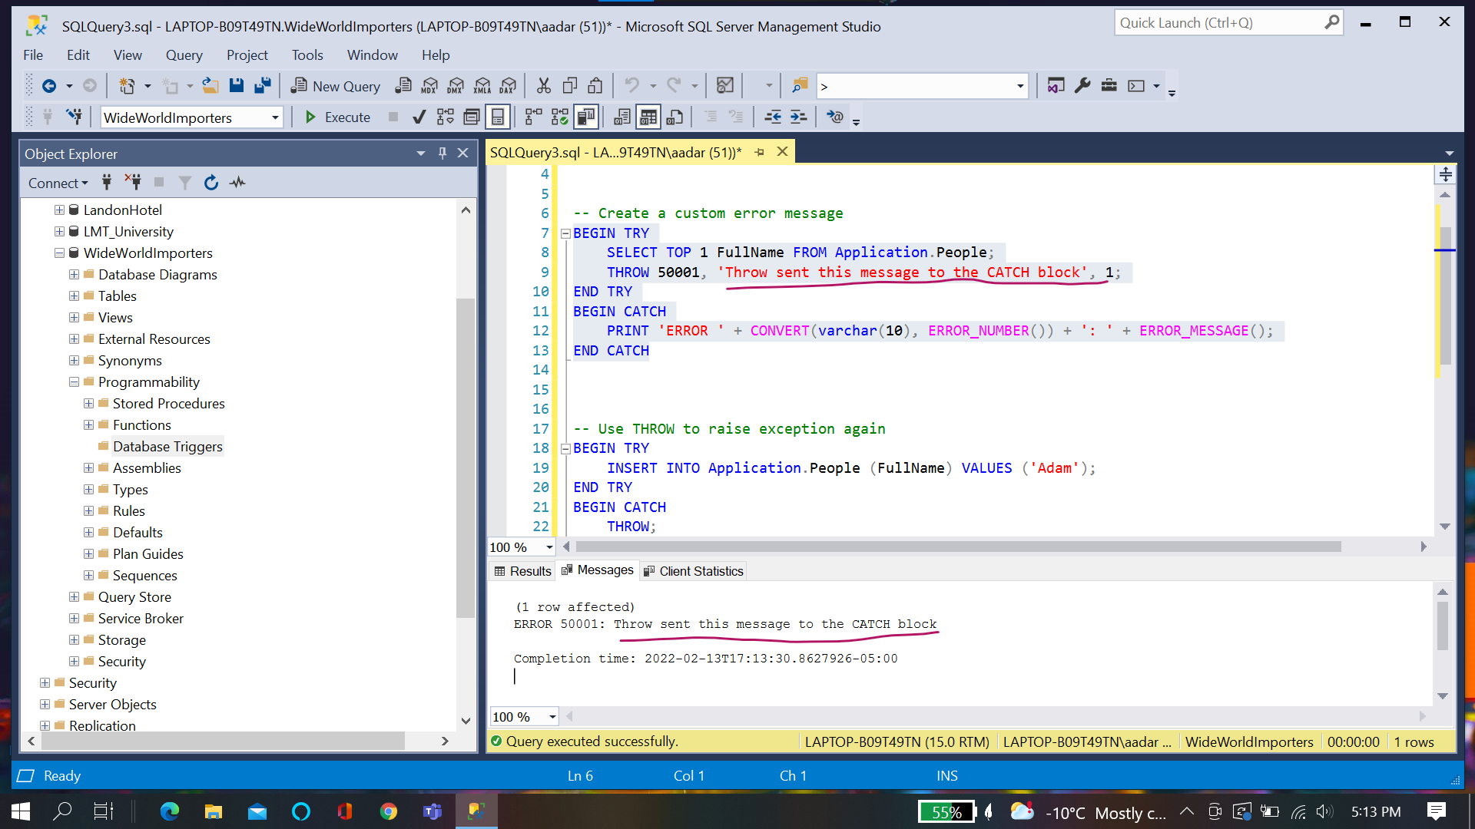

**Transaction Control:**

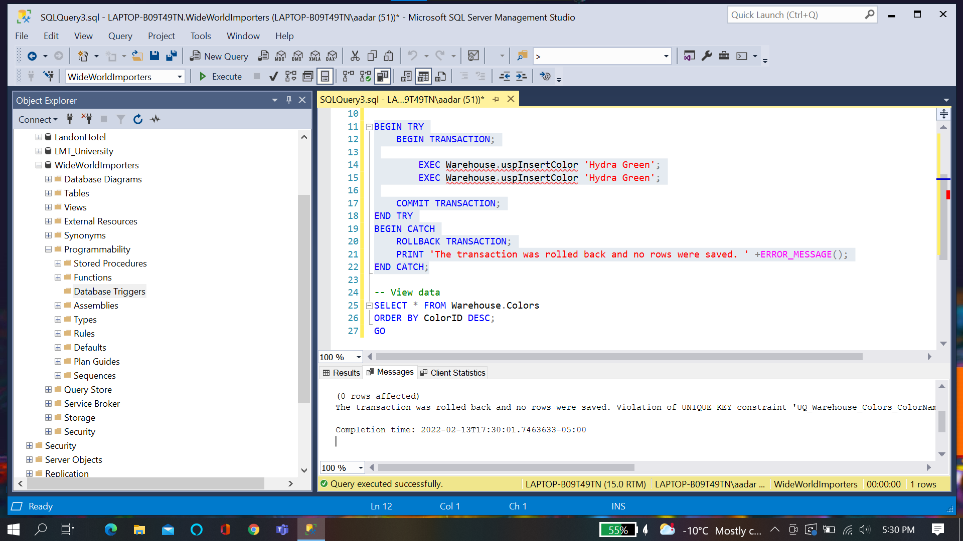

**Challenge:**

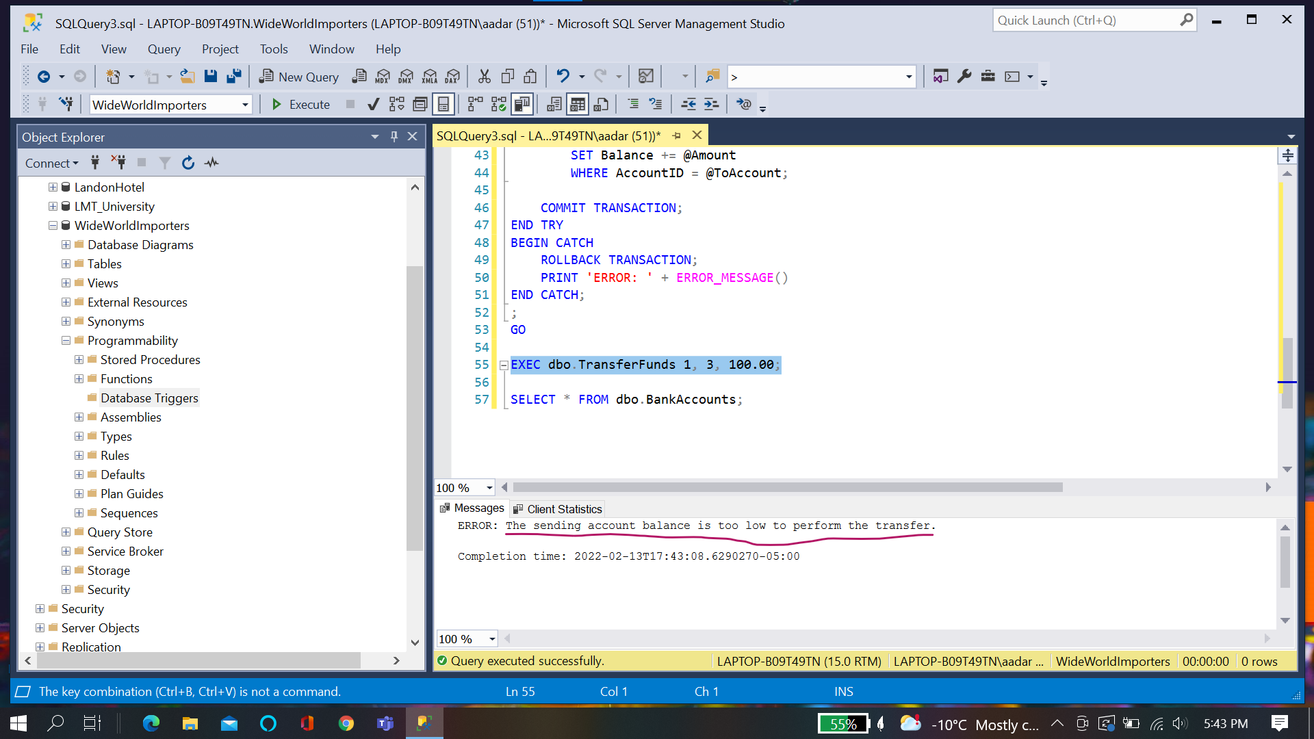

**Chapter Quiz:**

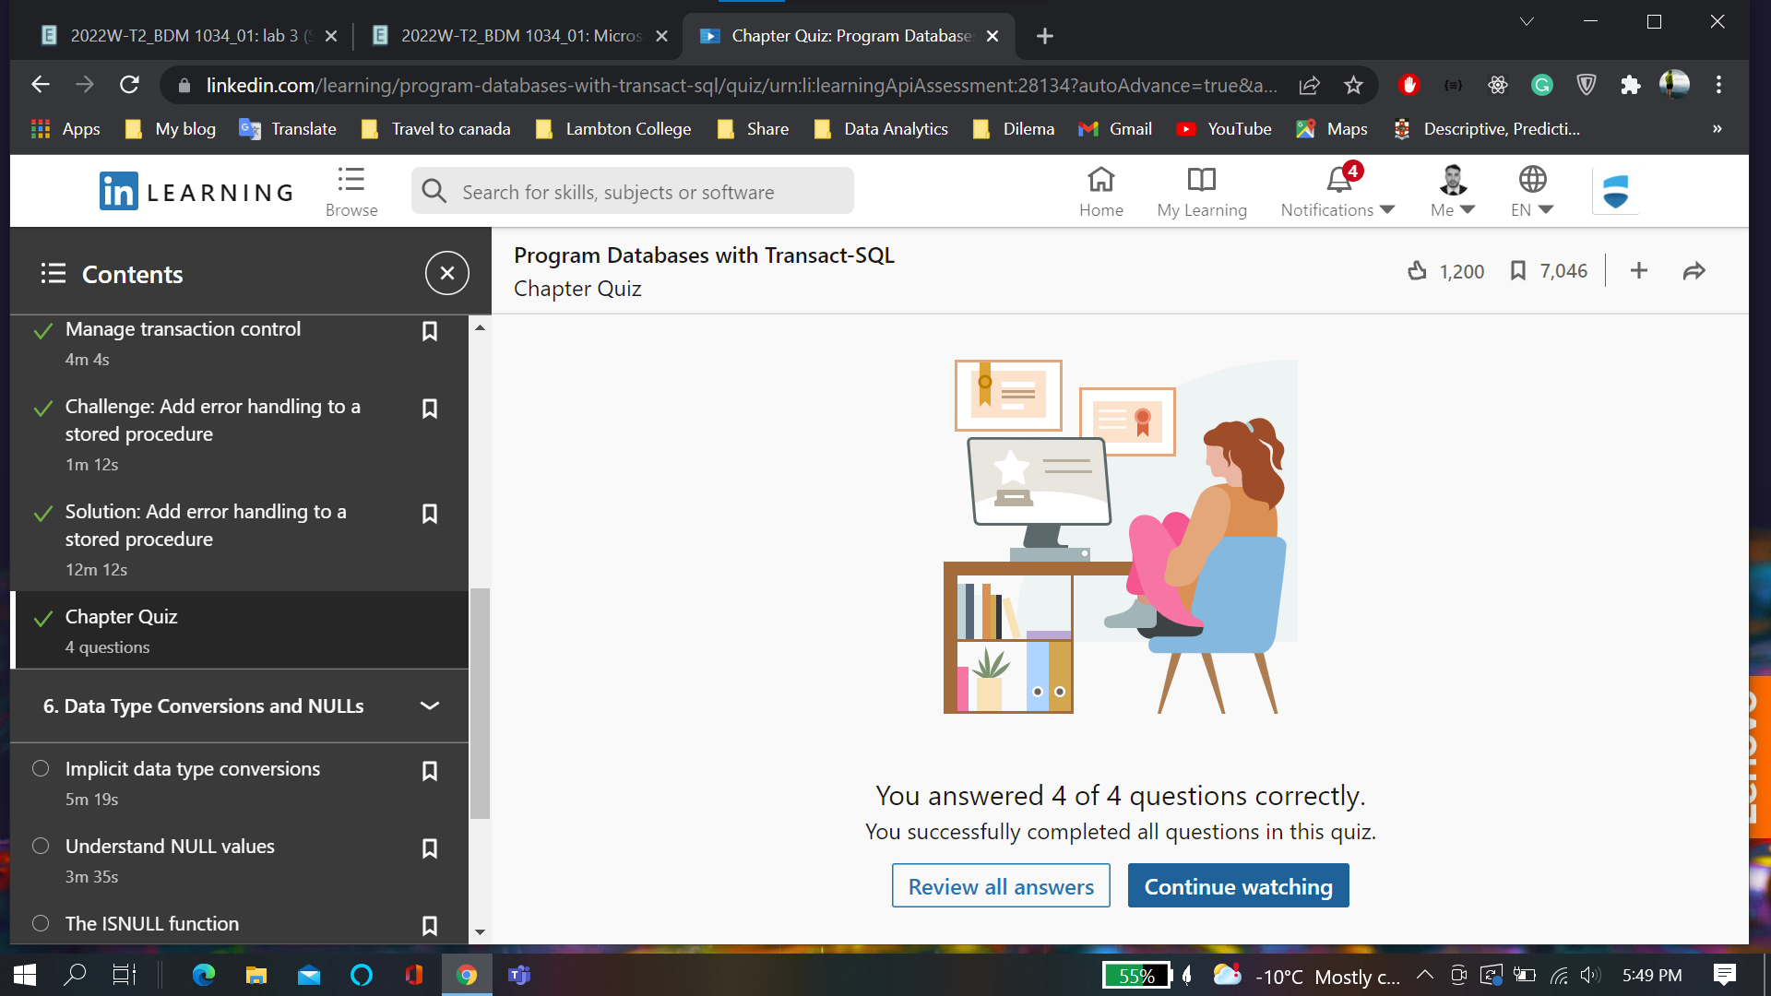

**Chapter 6: Data Type Conversion and NULL**

**Implicit Data types:**

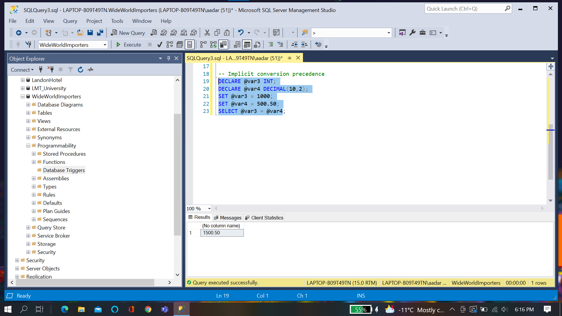

**Null Values:**

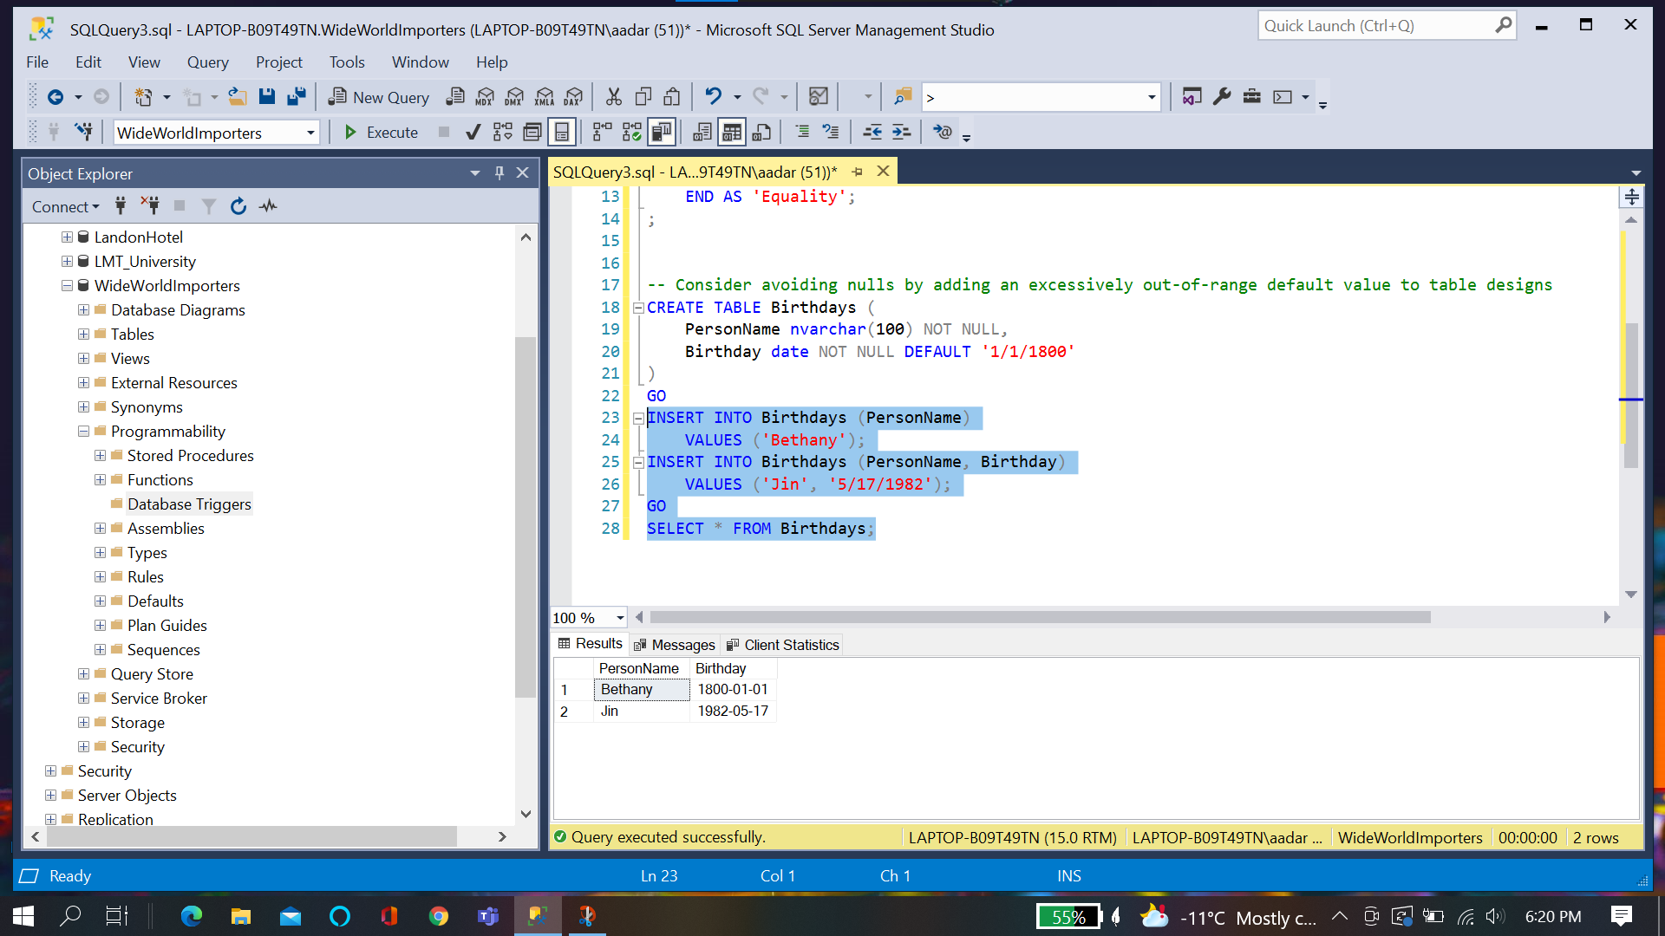

**IsNull Function**

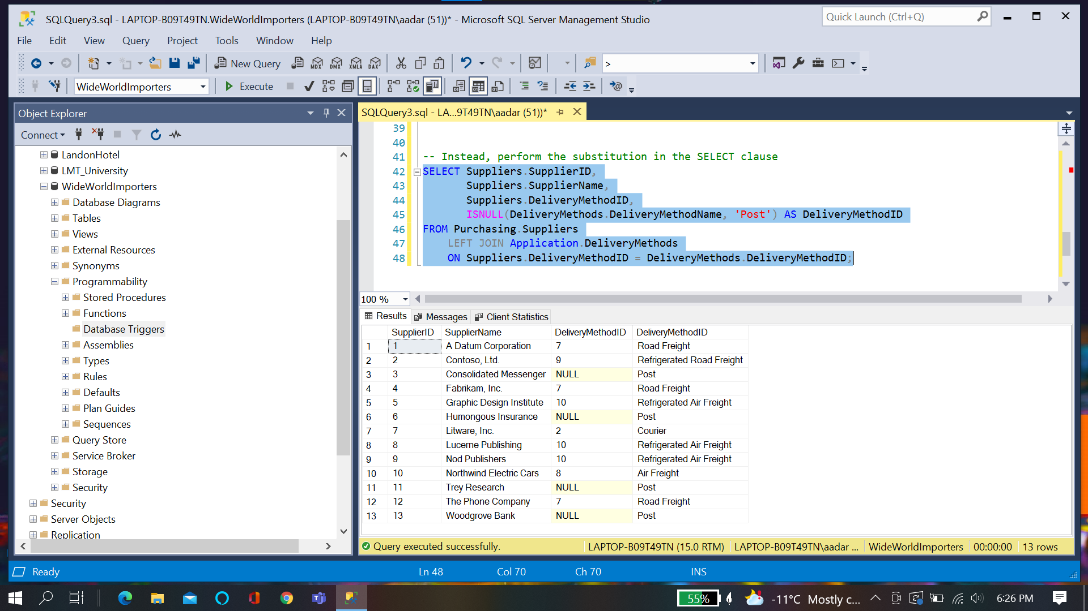

**Chapter quiz:**

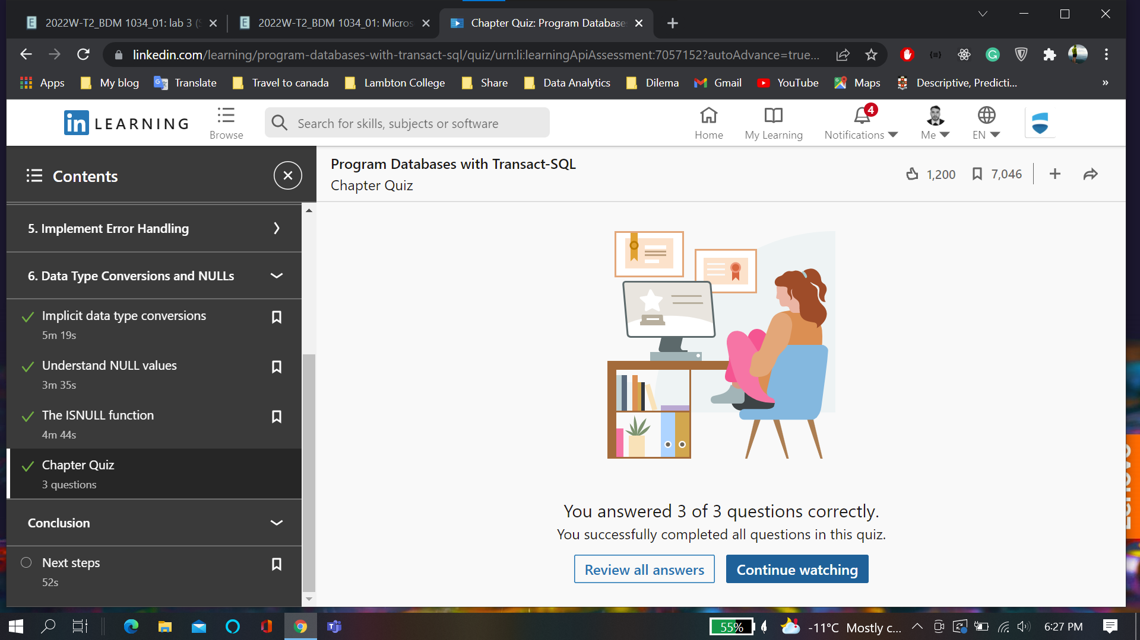

**Course Certification:**

